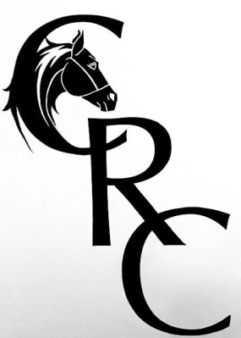
CALEDONIAN RIDING CLUB
BRAVE PANTS SHOWJUMPING
COMPETITION
WEDNESDAY 9TH SEPTEMBER

Maintaining standards as met by BRC and government guidelines.
Venue: Littleburn, Munlochy.
Kindly hosted by The Stewart Family.
Entries:
On the night. £8 (members) £12 (non members) Per class.

Start:- 4PM Please let us know if you are coming and what classes you are doing so we can adjust times accordingly. PM Facebook please
4pm Class1. 40cm
4.20pm Class 2. 50cm
5pm Class 3. 60cm
6pm Class 4. 70cm
7pm Class 5. 80cm

RULES OF SHOW
All horse droppings must be removed from the parking area.. All attendees will be responsible for any damage caused by them or their horses Committee members have the right to ask you to leave if no abidance by the rules or disrespectful of premises or judges etc.
A riding hat (that complies with current BRC standards) must be worn at all times when mounted. A body protector is discretionary. Suitable footwear is imperative and discretionary by judges and committee. All under 18s must be accompanied by a responsible adult at all times. Correct dress as per discipline see (BRC 2020 RULES). Welfare is the Riding Clubs top priority along with having fun, therefore any unacceptable behaviour you could be asked to leave. Photos may be taken and used on social media, please inform organisers if this is a problem beforehand

Contact number for track and trace
Member/ NON

Class

Horse

Rider

