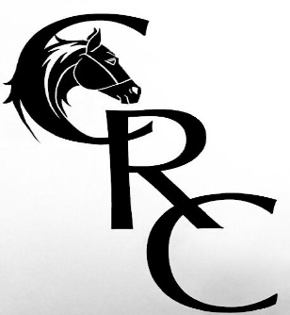
Caledonian Riding Club
Arena Event 5th April 2020

Venue: Black Isle Show Ground

Including the Clemmie BHS Scotland Riding Club Style Jumping Series 2020 and the Dodson & Horrell /BHS Scotland Riding Club Working Hunter Series 2020.
Final for both classes for the Blair International Horse Trials 2020
(by kind permission from the Black Isle Farmers Society)
Open to all: members and non-members

Arena Event
Class 1: 40cm Arena Event
Class2. 50cm Arena Event
Class 3. 60cm Arena Event
Class 4. 70cm Arena Event
Class 5. 80cm Arena Event
Class 6. 90cm Arena Event
Class7. 100cm arena Event
Class 8. 100cm The Dodson & Horrell /BHS Scotland Riding Club Working Hunter Series 2020 Judge: Mr D Scott-Downie
The course: At least 8 and not more than 12 fences, with changes of direction, must be set in a ring large enough to permit jumping fluently at a fair hunting pace. Fences should be rustic or as natural as possible, not easily dislodged, of solid appearance, well filled and dressed, for example with shrubs as wings. Maximum height 3ft 3ins (1.00m), maximum spread 3ft 6ins (1.05m), except open ditch and water. As this is a qualifier for a national final, the course should be set at, or near, maximum unless the judge considers that the ground makes this unsafe. Normally at least one upright and one spread must be at maximum.
Qualification: The first THREE qualify for the final, even if they did not jump clear. If one of the first three has already qualified the qualifying card can be passed down to fourth place provided, the 4th placed rider jumped clear. If a class has less than 4 entries only the winner will qualify for the Championships.

Showjumping
Class 9. 40cm Showjumping
Class 10. 50cm Showjumping
Class 11. 60cm Showjumping
Class 12. 70cm Showjumping
Class 13. 80cm Showjumping
Class 14. 85cm Showjumping. The Clemmie BHS Scotland Riding Club Style Jumping Series 2020 Judge: Ms C Molyneux.
Eligibility: Horses must be 4yo or over. No height restrictions. Horses must have not won more 5 BE points or 200 BS points. Riders must be 18yo or older on 1 Jan 2020 and must not have competed in any FEI competition or be an FBHS or have taken their BHSII exams in the last 10 years. To compete at the final, the rider of the horse must be a member of a riding club affiliated to BRC.
The course: You will be asked to jump a course of 7 fences, including a stile fence and a double, at a speed of 325m per minute. Maximum height in qualifiers and at the final is 85cm, max spread is 90cm. The course will be built to encourage a flowing round.
Qualification: The first three partnerships will qualify for the final. If there are less than three entries, only the first partnership will qualify.
Class 15. 90cm Showjumping
Class 16. 100cm Showjumping
Class 17. 110cm Showjumping

RULES OF SHOW
All horse droppings must be removed from the parking field. All attendees will be responsible for any damage caused by them or their horses Committee members have the right to ask you to leave if no abidance by the rules or disrespectful of premises or judges etc.
A riding hat (that complies with current BRC standards) must be worn at all times when mounted. A body protector is discretionary. Suitable footwear is imperative and discretionary by judges and committee. All under 18s must be accompanied by a responsible adult at all times. Correct dress as per discipline see (BRC 2020 RULES).

Welfare is the Riding Clubs top priority along with having fun, therefore any unacceptable behaviour you could be asked to leave.

Rules for W.H and Style jumping to follow British Riding Clubs 2020 handbook.
[All non-members must have their own suitable insurance]. All horses must be vaccinated within 1 year and you must bring your passport with proof of vaccination as they WILL be checked by the venue or CRC BEFORE UNLOADING OF HORSES (SEE parking attendant before unloading). Unvaccinated horses will not be allowed to attend, and you must not bring your horse if it, or others at its yard, exhibits any unexplained respiratory problems.

Well behaved dogs are permitted (but not encouraged). Dogs must always be kept on non-extendable leads.

Only 3 classes per horse and rider combination to be entered.

Photos may be taken and used on social media, please inform organisers if this is a problem beforehand. Otherwise it will be taken as fine for use.

Closing date: 22nd March 2020 NO LATE ENTRIES WILL BE ACCEPTED FOR QUALIFIER CLASSES

Other classes late entry at double fee.

Entries via EQUO EVENTS or Heather Maclennan, Suil Na Mara, Westhill, Inverness IV25GX

Chèques payable to : Caledonian Riding Club

Maximum 3 classes per horse. Classes start at 10am prompt.

Price per class: £8 members, £12.50 non-members.

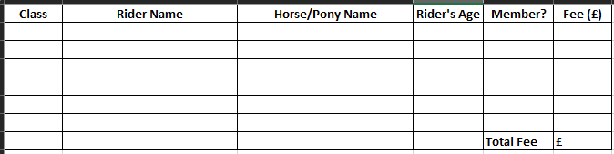

I AGREE TO ABIDE BY THE SHOW RULES.
Signed __________________ Date ______
Name _______________________ Tel no ______________________
Address _________________________________________________
Email ___________________________________________________
Emergency Contact name and phone number: ________________________________

