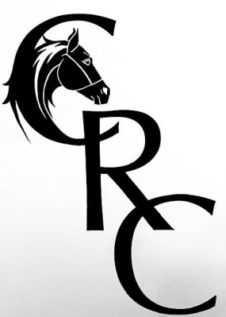
CALEDONIAN RIDING CLUB
FUN RIDE OUT
(Macmillan charity ride)
Maintaining standards as met by BRC and government guidelines.
Venue: Brookfield, Leanach Farm Culloden Moor
Kindly hosted by the Mackay family
Entries: Close by 9th September
PM CRC (Facebook) and Bank transfer or send to -:
Cheque: Caledonian Riding Club
c/o Becky Milns CRC 10 Alder place, Culloden IV27LG

£15 for members, £25 for non-members with £10 reduction if you are doing the MacMillan Charity Ride
There will be two routes available, a short 3.5 mile (CLASS 1.) route suitable for lead-rein riders with no road work required and a longer 8 mile route (CLASS 2.) with a short section of single track road. Both routes will be mostly through forestry.
The date coincides with the MacMillan Charity Ride 2020. Anyone who would like to participate in this challenge can enter using the link below. There is an additional entry fee for MacMillan of £20 but this is automatically added to your fundraising total and you will receive a rosette for participating in the challenge. There is also a photo competition and the chance to win a luxury riding holiday for the person who raises the most for the charity. See the MacMillan Charity Ride 2020 Facebook page for full details. A member of the CRC committee can verify your participation in our fun ride to qualify your distance for your fundraising.
Participation in the MacMillan Charity Ride is not required in order to come along and enjoy the CRC Fun Ride Out but we thought many of our members might like the opportunity to combine the fun ride with a worthy cause.
Full ride details will be emailed to participants in the week before the 12th September. Please ensure your email address is included with your entry.
https://cdn.fbsbx.com/v/t59.2708-21/117681556_221438265861586_3510392847734010482_n.pdf/2020-Charity-Ride-Form.pdf?_nc_cat=110&_nc_sid=0cab14&_nc_ohc=DNFaLirT6QQAX8b1obT&_nc_ht=cdn.fbsbx.com&oh=a30825b4cb1e3abb2fad32e514fade6a&oe=5F38551F&dl=1

RULES OF FUN RIDE OUT
All horse droppings must be removed from the parking area.. All attendees will be responsible for any damage caused by them or their horses Committee members have the right to ask you to leave if no abidance by the rules or disrespectful of premises or organisers etc.
A riding hat (that complies with current BRC standards) must be worn at all times when mounted. A body protector is discretionary. Suitable footwear is imperative and discretionary by organisers and committee. All under 18s must be accompanied by a responsible adult at all times. Welfare is the Riding Clubs top priority along with having fun, therefore any unacceptable behaviour you could be asked to leave. Photos may be taken and used on social media, please inform organisers if this is a problem beforehand.

ENTRY FORM FOR FUN RIDE OUT 12TH SEPTEMBER /Culloden Moor
RIDER HORSE CLASS MEMBER OR NON CONTACT NUMBER
Contact number for track and trace
EMAIL ADDRESS FOR RIDE DETAILS
Member/ NON

Class

Horse

Rider

EMAIL ADDRESS
REQUIRED

